Running head: Appoo et al.Coconut crab population dynamics on Aldabra

**Population dynamics of the coconut crab (*Birgus latro),* on Aldabra Atoll, Seychelles**

Jennifer Appoo1[1]✝, E. Fernando Cagua1,2✝, Janske van de Crommenacker1, April J. Burt1,3, Pierre Pistorius1,4, Frances E. Taylor1,5 , Heather Richards1,6, Philip Haupt 1,7,Naomi Doak1, Frauke Fleischer-Dogley1,and Nancy Bunbury1,8

*1Seychelles Islands Foundation, Victoria, Mahé, Seychelles;*

*2Center for Integrative Ecology, School of Biological Sciences, University of Canterbury, Christchurch 8041, New Zealand;*

*3Department of Plant Sciences, Oxford University, South Parks Road, OX1 3RB, UK;*

*4Department of Zoology and Institute for Coastal and Marine Research, Nelson Mandela University, Port Elizabeth, South Africa;*

*5Softfrog cc, Port Elizabeth, South Africa;*

*6Royal Society for the Protection of Birds*

*7Ichthyology Department, Rhodes University, Prince Alfred St, Grahamstown, 6139, South Africa, Grahamstown, South Africa;*

*8Centre for Ecology and Conservation, University of Exeter, Cornwall Campus, Penryn, TR10 9FE, Cornwall, UK*

ABSTRACT

*Birgus latro* plays a significant role in recycling nutrients in ecosystems, but has been extirpritated from most of its range throughout the Indian Ocean Islands. The shortage of information on *B. latro* has left this species classified as Data Deficient on the IUCN’s Red List, and consequently limited resources are available for conservation efforts. Information on the spatiotemporal dynamics and demography of this species will provide critical information to improve knowledge of the species in an effort to address its IUCN Red List status.

Aldabra, an atoll in the Seychelles, has an unexploited and protected population of *Birgus latro* . We aimed to quantify the demography and spatio-temporal dynamics ofa large and unexploited population of *B. latro* at Aldabra Atoll from 2007 to 2016 (nine years). Based on results from a relatively small study area on the atoll, we coarsely extrapolated population numbers to bebetween 4314 and 88,872 individuals with numbers within the study area being largely stable over the study period. The population exhibited high spatial and temporal variability in density, size and sex ratio over this time period and in association with the lunar cycle. Aldabra’s *B. latro* population is strongly male-biased (3:1 male to female), as elsewhere, and is sexually dimorphic, with males (often reaching over xx.x kg) attaining much larger sizes than females (often reaching over ..). Males and females moulted at different times of the year and the breeding season overlapped with the region’s wet season (December–March), and in synchrony with the phase of the moon. Results validates that Aldabra is an important refuge for *B. latro* and may be an important source population from where to repopulate other protected areas in the Western Indian Ocean where populations have declined substantially. Our study contributes much needed information to revise the IUCN Red List threat status of *B. latro*, currently listed as Data Deficient and to leverage conservation efforts for this species.

KEY WORDS: *Birgus latro*, population size, spatio-temporal variability, seasonal dynamics, moulting, reproductive season, Aldabra Atoll.

1. INTRODUCTION

Around 15,700 species are classified as Data Deficient on the IUCN Red List, meaning that their threat status cannot be assessed due to inadequate information in species taxonomy, distribution, population status or threats (IUCN, 2019). These uncertainties influence the likelihood of active conservation measures being adopted. Unless directly targeted for monitoring, species classified as data deficient can become extinct or locally extinct before protective measures are put in place (Bland et al. 2014). New information on Data Deficient species may therefore help fill data gaps in biodiversity indicators, as well as conserve poorly known taxa (Bland et al. 2014). Invertebrates attract less conservation attention than that of vertebrates (Collen et al. 2012), yet it is crucial to understand the conservation status and trends of invertebrates, since these species are key components for the functioning of ecosystems (Baillie et al. 2010).

In tropical island ecosystems, crabs, in particular, play a crucial role in nutrient cycling and food chains. The largest land arthropod, the coconut crab (*Birgus latro*)*,* is classified as Data Deficient by IUCN (Eldredge 1996) due to limited information on the status of the different populations (Drew et al. 2010). Although *B. latro* has a broad geographical range across the tropical Indo-Pacific region, the size and distribution of the populations have substantially reduced in human-inhabited areas (Schiller 1992). This decline is mostly attributed to loss of habitat, predation in juvenile stages by invasive species such as rats and unmanaged harvesting for human consumption (Laidre 2018). In the Indian Ocean the distribution of *B. latro* is now largely confined to three populations; Aldabra Atoll (Seychelles), the Chagos Archipelago (BIOT) and Christmas Island (Australia; Lavery et al. 1996) and are also found in the Tanzanian islands; Caro & Morgan 2018). *Birgus latro* is locally extinct in Mauritius (Eldredge 1996) and is believed to no longer occur on Mayotte and the Comoros Islands, although a few individuals has recently been re-discovered on Glorieuse for the first time in more than a century (Poupin et al. 2013). In the Seychelles, *B. latro* has been historically overexploited for food on the granitic inner islands and inhabited outer islands. With the exception of Aldabra Atoll, *B. latro* occurs throughout the Seychelles in low incidence with recent opportunistic records on two granitic islands and the species has only been occasionally recorded on some of the outer Seychelles islands (Poupin et al. 2013). Very little is, however, known on the species’ life-history, behaviour and ecological requirements limiting assessment of its Red List status and development of potential conservation measures (Drew et al. 2010).

Where they do occur, *Birgus latro* plays an important ecological role on island ecosystems (Paulay & Starmer 2011, Laidre 2017). Being highly omnivorous, *B. latro* feeds on a variety of plants and animals and actively scavenges (Krieger et al. 2016). As scavengers they remove rotting material, help to decompose leaf litter and their consumption of seeds and seedlings control plant numbers (Alexander 1979). As they breed by means of marine larvae, the species contributes to the transfer of energy and material between sea and land. *Birgus latro* also actively hunt (Krieger et al. 2016, Laidre 2017), suggesting they may function as top predators in their island ecosystems (Laidre 2018). Furthermore, juvenile *B. latro* are a food source for birds and contribute to soil aeration and erosion through their burrowing activities (Alexander 1979).

On Aldabra, *B. latro* has benefited from complete protection since the atoll’s designation as a Special Reserve in 1981 and inscription as a UNESCO World Heritage Site in 1982. *Birgus latro* is abundant and widely distributed across the atoll, inhabiting rock crevices, deep pot-holes, vegetation and sandy areas (Grubb 1971). The species is an important scavenger of dead Aldabra giant tortoises (*Aldabrachelys gigantea*), and preys on marine turtle eggs and hatchlings (Haig 1984). Although one of the few remaining viable populations in the Indian Ocean, the status and ecological characteristics of Aldabra’s *B. latro* population have never been documented.

The key criteria of the IUCN’s Red List criteria address matters such as a change in the area of occurrence, a change in the overall extent of the species range, population declines and fragmentation (REFERENCE See ATTACHED IN EMAIL)..Aldabra also provides the opportunity to understand if a change in population is caused by environmental drivers, opposed to anthropogenic drivers, as the species is protected and there is no harvesting of B. latro since 1981.

Here we investigate population characteristics, dynamics and behavioural patterns in *B. latro* on Aldabra based on a nine-year study, where fortnightly counts and biometric data were collected on this populationbetween 2007 and 2016. In particular, we aimed to: (1) estimate population density and temporal patterns in population numbers; (2) assess habitat preferences and activity patterns;; (3) assess sex ratio and population size distribution; and (4) assess moult cycles (to determine whether there is synchronous seasonal moulting) and timing of breeding and whether this is related to lunar phase. In addressing these questions we provide baseline information on the life history and population dynamics for one of the few remaining relatively pristine populations of *B. latro* relevant to future monitoring and conservation strategies for this species.

2. MATERIALS AND METHODS

2.1. Study site

Aldabra Atoll (9°25′0″ S, 46°24′59″ E; land area 155 km2) is a large (34 km × 14 km) raised atoll in the Western Indian Ocean, which forms part of the Seychelles archipelago. It is ca. 1100 km south-west of Mahé, the main island of the Seychelles, and ca. 400 km north of Madagascar (Fig. 1). Aldabra is composed of a characteristic and irregular coral limestone formation called ‘champignon’. The terrestrial environment is dominated by dense scrub of varying height, either continuous or in a mosaic with open rocky ground (Hnatiuk & Merton 1979). Aldabra’s climate is defined by two distinct seasons: the wet season of the north-west monsoon from November to April (Stoddart & Mole 1977), while between May to October there is lower rainfall resulting from the south-east trade winds.

2.2. Survey design and sampling

The distribution of *Birgus latro* is thought to be structured by distance from the coastline (Schiller 1992). Population surveys of *B. latro* were conducted along two transects established on existing walking trails at different distances from the shore (Fig. 1) on the island of Picard, one of the four islands of Aldabra. Both transects were divided into 50 m sections. The ‘shore’ transect was 1.4 km long and 1–26 m from the shore (high water mark). The ‘inland’ transect was 1.8 km long and 38–177 m from the shore. We surveyed each transect (two people walking the transects, taking an average of 90 mins) after sunset, every two weeks between January 2007 and May 2016.

All *B. latro* individuals encountered within 5 m on either side of the mid-transect line were recorded. For each individual encounter, we recorded the following parameters: (i) distance to the mid-transect line (estimated to nearest meter); (ii) sex (female *B. latro* possess three large, feathery pleopods on the ventral surface of their abdomen to support their egg-masses; Fletcher 1993), and for females, whether carrying eggs or not; (iii) thoracic length (linear distance between anterior and posterior borders of the thoracic groove, measured with Vernier calipers; Helfman 1973 cited by Amesbury 1980); (iv) moult, measured as the degree of pleonal expansion (Amesbury 1980, Fletcher et al. 1990, Held 1963 cited by Drew et al. 2010) using a four-level categorical scale: category: (1) all tergal plates touching each other or only a small gap between the most posterior tergal plate (first plate) and the second plate; (2) pleon slightly swollen and fleshy abdomen visible between first and second plates, and somewhat visible between second and third plates; (3) pleon swollen and fleshy abdomen clearly present between first, second and third plates, and somewhat visible between third and fourth plates; and (4) strongly swollen pleon with fleshy abdomen visible between all tergal plates.

2.3. Habitat classification

To control for potential habitat effects, we used a habitat classification (Walton et al. 2019) to determine the eight habitat categories that were intersected by the transects.. In each 50 m transect section we calculated the percentage of area occupied by the different habitat types by counting the number of pixels of each habitat type that overlapped with the transect area .

2.4. Data analysis

2.4.1. Density and abundance

We estimated the density of *B. latro* during using the hierarchical distance sampling model of Royle et al. (2004) implemented in the R package ‘unmarked’ (Fiske & Chandler 2011). We used the numbers of individuals within five distance categories 0−1, 1−2, 2−3, 3−4, and 4−5 m from the mid-transect line to estimate the overall density and evaluated the association between habitat with both the detectability and abundance of *B. latro*.

Due to the large number of surveys, we used a meta-analysis to ascertain the overall importance of habitat. Specifically, we fitted four models for each survey. In the first, we assume that habitat influence both detectability and density. In the second and third model, we assume that habitat only influences detectability and density respectively. In the fourth model we assume that both detectability and density are independent from the habitat. Then, for each survey we compare these four models using the Akaike Information Criterion (AIC) and determine the difference between each model’s AIC and the smallest AIC (∆AIC). Finally we calculated the median ∆AIC for each model across all surveys to determine which of the four models performed better overall.

Next, we used a generalised additive model (GAM) to determine whether *B. latro* densities varied significantly (i) over the years, (ii) over the yearly cycle, and (iii) over the lunar cycle. We fitted the models using the R package ‘mgcv’ (Wood 2006a), and assessed the model parsimony by comparing their AIC values, with models with the lowest AIC values presenting the most parsimonious (best fitting) models. We back calculated the phase of the moon during the survey using the R package ‘oce’ (Kelley & Richards 2015) and defined it as a continuous variable from zero to one with both extremes corresponding to new moon, 0.25 for first quarter, 0.5 for full moon, and 0.75 for last quarter (Meeus 1982). In order to assess potential sex-specific differences a finer spatial and temporal scale, we used a set of GAMs to quantify the relative effect of the aforementioned variables on the counts of both male and female individuals independently. This was possible after initial analysis indicated that *B. latro* detectability was not consistently influenced by habitat composition (see Results) and consequently direct counts are sufficiently correlated to *B. latro* observable densities. It is also plausible that environmental factors interact with habitat requirements. Because Aldabra’s weather is highly seasonal and environmental factors like rainfall, temperature, and wind, are highly correlated with the day of the year, we included in the model an interaction between day of the year and distance from shore was included in the model (Wood 2006b).

2.4.2. Sex ratio and size

We calculated overall observed sex ratios from the individual. Because of the relevance for reproduction, we also calculated the sex ratio of only sexually mature individuals. We assumed sexual maturity based on size: individuals with a thoracic length > 28mm were considered adults (Fletcher et al. 1990, Drew et al. 2010). We used thoracic length to determine whether the Aldabra population exhibits size sexual dimorphism. We evaluated the difference by visually inspecting the size distribution for both sexes and performing Mann–Whitney tests on the thoracic length measurements. We used a set of GAMs to infer the effects that time of year, distance from shore, and lunar phase may have on the sex ratio and sizes of individuals encountered.

2.4.3. Moulting and reproduction

We constructed two additional GAMs, one for each sex. In these models the response variable was the index of pleonal expansion (treated as a numeric variable) and the predictor was time of year. To determine the reproductive season of *B. latro* on Aldabra, we constructed a GAM with a binomial error distribution with the response variable being whether a female was seen carrying eggs during a survey transect or not, with time of year and lunar phase as response variables.

3. RESULTS

3.1. Density changes over time and population estimate

Overall, 265 surveys were completed over the study period with 8145 *B. latro* encountered. We found that overall the most parsimonious models were those that assumed no influence of habitat on neither detectability and density. Specifically, the median ∆AIC of models in which we assumed that both detectability and density are independent from the habitat was 0.35 (min. 0, max. 71.5), while that of the models in which we assumed that habitat influenced both was 8.35 (min. 0, max. 22.2). The median ∆AIC of models in which habitat influences only detectability or density was 3.25 (min. 0, max. 45.2) and 4.35 (min. 0, max. 38.7) respectively. The high variability in ∆AIC values within each model type suggests that, for some surveys, habitat differences help explain the variability in detectability and/or density. However, the differences between medians was large enough for us to calculate crab densities and abundances ignoring habitat effects.

*Birgus latro* density in the study area ranged between 2.95–105.36 ind. ha-1, with an average density of 23.7 ± 1.1 ind. ha-1 (mean ± SE) across both transects. The density showed small variations between years, but with no apparent long-term trend (Fig. 2A). The overall mean detectability of *B. latro* was 0.48, which corresponds to an effective strip half-width of 2.4m.

The population size of *B. latro* was estimated using two approaches, taking into account the furthest distance of our transect from the shore (177 m). Since habitat type did not have an effect on *B. latro* density in the areas covered by our transects, the first method extrapolated the density to total surface area using the total perimeter of the outer rim of the atoll (211.86 km) , which produced a mean population size of 88,872 ± 4875 *B. latro* on Aldabra*.* *.* However, since crabs need access to the shore for reproduction and feeding, we also extrapolated the value for only area with appropriate beach nearby (total length of beach coastline 10.29 km), which produced a population estimate of 4314 ± 237 *B. latro*.

3.2. Effect of season, habitat and lunar phase

The number of *B. latro* encountered was above average (> 23.7 ind. ha-1) between February and June, with a clear peak in April, and below average between July and December (Fig. 2B). The abundance of *B. latro* males and females was strongly affected by the time of year and the distance from shore. In general, more males were encountered January–June than July–December. In March and April, males were concentrated away from the shore (Fig. 3A) and more females were encountered closer to shore. In contrast, during July–December, when fewer males were seen, female density was higher on both shore and inland transect areas, particularly between October and November (Fig. 3A).

There was no variation in density with moon cycle (p = 0.916). Although moon phase did not affect overall *B. latro* densities, it had distinct effects on males and females (Fig. 4A), with females being most abundant during periods of full moon, and males during new moon.

3.3. Sex ratio and size

The overall *B. latro* sex ratio of observed individuals was approximately 3:1 (76% male; n = 6536), and approximately 4:1 (82% male; n = 5582) for sexually mature individuals. This ratio shows temporal and spatial variation, ranging from 57% of individuals encountered being male during November along the transect close to shore to 86% during March along the inland transect.

A marked size sexual dimorphism was observed (Fig. 5), with males being larger (mean male thoracic length: 40.9 mm; range: 9–78 mm; n = 6536) than females (mean: 30.6 mm; range: 6–76 mm; n = 2071). Although the size distributions of males and females did not differ (n1 = 6182, n2= 1994; p = 0.725), large males were significantly larger than females (Mann–Whitney of upper decile, n1 = 666, n2 = 197; p < 0.001). The mean size of both male and female individuals encountered showed two distinct and synchronous peaks during the year, one between October and December, and another more pronounced between March and May (Fig. 3B).

Mean size was also affected by the distance to shore, with females encountered close to shore being larger than those encountered inland. In contrast, males encountered inland were larger than those close to shore. This difference in males encountered, however, becomes inconspicuous in December and January and from June to August (Fig. 3B). Furthermore, males encountered close to new moon were larger than males encountered close to full moon, while females showed no size variation over the lunar cycle (Fig. 4B).

3.4. Moulting and reproduction

Males with a thoracic length over 30 mm exhibited an annual cycle in pleon size, with a peak in April and May (Fig. 6), while female pleons were largest in November with a less conspicuous peak of pleon expansion between June and July (Fig. 6). Throughout the monitoring period, only 14 *B. latro* females (of 2071 individuals in 12 of 484 transects) were ovigerous, with the timing of encounters indicating a reproductive season between December and March with an increased encounter probability just before new moon (Fig. 7).

4. DISCUSSION

To our knowledge, our study presents results from the longest continuous monitoring programme of *Birgus latro* to date, and suggests that Aldabra hosts one of the largest *B. latro* populations worldwide (with 4314–88,872 individuals), likely as a consequence of decades of protection. Published data on population sizes of unharvested populations is rare and outdated, the only other two unexploited populations of *B. latro* with published studies (Drew et al. 2010) are estimated at 41,865 ± 4728 crabs on Taiaro, French Polynesia (Chauvet & Kadiri-Jan 1999) and 300–1200 crabs on Ikuren Islet, Enewetak Atoll, Marshall Islands (Reese 1987 cited by Fletcher 1991). The Chagos Archipelago, Palmyra Atoll and Christmas Island are also important strongholds for *B. latro* (Laidre 2018) but no *B. latro* population estimates are currently available for these islands. The population on Christmas Island experiences limited exploitation and has suffered significant decline (Drew & Hansson 2014). The stable population at Picard suggests that the species is not undergoing a natural decline in the Indian Ocean, and suggests that elsewhere in the region where declines have occurred could be attributed to anthropogenic causes.

We found substantial spatial and temporal heterogeneity in *B. latro* density, size and sex over the study period. Adult *B latro* are not sessile but are in constant movement locally around their home site and can undertake long-distance (up to 4.2 km) movements (Krieger et al. 2012). This is linked with their complex life cycle associated with reproductive migrations, moulting requirements, availability of resources and behavioural variations associated with environmental conditions at a site (Drew & Hansson 2014). The peak in the number of crabs observed from February to May is largely due to an increase in the number of active males in the study area. During this period, large dominant males favoured inland areas, presumably richer in resources, while females and smaller males were mostly encountered in near-shore habitats. Drew and Hansson (2014) noted that large males often actively exclude females and smaller males from preferential feeding areas. Later in the year, from June to December, the overall number of *B. latro* drops, again largely due to a decrease in the number of males, particularly of large ones, which are potentially undergoing moulting during the drier months of the year (Fletcher et al.1991). *Birgus latro* undergoes moulting in shallow burrows to minimize vulnerability to predation and desiccation during the moulting process (Drew et al. 2010). Contrastingly, female counts increased in the second half of the year, potentially exploiting the available resources in preferred feeding areas after vacated by dominant males (Drew & Hansson 2014). Female densities peaked between September and December near-shore which coincided with a period in which males of sexually active sizes are commonly encountered. This suggests a breeding migration of female *B. latro* involving females moving to the shore to release larvae into the ocean (Schiller et al. 1991). Tracking studies from Christmas Island shows that male *B. latro* also move closer to shore for reproductive purposes but remain for a shorter period (Krieger et al. 2012).

At the spatial scale of this study, sex ratio appears to be biased towards males, which may be a result of the sampling design. Transect studies typically report male bias ratios compared to grid sampling and are sensitive to variations in habitat use between sexes (Drew et al. 2012). Female *B. latro* have been shown to have affinity to denser vegetation and are therefore less likely to be encountered on transects along existing paths (Drew et al.2012). Furthermore, James (2008) suggested that female *B. latro* are more sedentary outside the breeding season, indicating that the males are wider ranging, increasing their chances of being encountered in surveys along pathways.

All studied island populations of *B. latro* to date show males to be consistently larger than females (Drew et al.2010, Anagnostou & Shubart 2014). Similarly, *B. latro* on Aldabra is sexually dimorphic, with males attaining larger sizes than females. The maximum size of the thoracic length of both male and female *B. latro* recorded on Aldabra is larger than other studied populations. However, the sexual dimorphism of *B. latro* at Aldabra was supressed, with almost no difference in maximum thoracic lengths between males and females (Aldabra: male = 78 mm, female = 76 mm; Igurin, Marshall Islands: male = 74 mm, female = 52 mm; Guam, Mariana Islands: male = 76 mm, female = 47 mm; Niue: male = 53 mm, female = 36 mm; Lifou, New Caledonia: male = 76 mm, female = 46.5 mm; Vauvilliers, New Caledonia: male = 76.5 mm, female = 57.5 mm; Taiaro, French Polynesia: male = 66.5 mm, female = 60 mm (Chauvet & Kadiri-Jan 1999, Drew et al. 2010), Christmas Island: male = 72.5 mm, female = 50.3 mm (Anagnostou & Shubart 2014).

Based on encounters with ovigerous females, the reproductive season of *B. latro* on Aldabra apparently occurs between December and March, during the rainy season for this region. This also corresponds with the period of highest peak of female pleonal expansion in November to December, which is related to gonad development (Fletcher et al. 1991, Sato & Yoseda 2009). This period coincides with the reproductive seasons observed in other *B. latro* populations in the southern hemisphere (e.g. Christmas Island, New Caledonia; Drew et al.2010). Moreover, signs of synchrony with the lunar phase were found as most ovigerous females were encountered during surveys close to new moon. This synchrony is likely related to the timing of spawning or egg extrusion (Sato & Yoseda 2009). The few studies detailing mating behaviour in *B. latro* indicate that copulation is brief and not preceded by elaborate courtship (Schiller et al. 1991). The timing between mating and egg extrusion is unknown, but as female individuals do not possess a seminal receptacle, it is believed that egg extrusion occurs shortly after mating (Sato & Yoseda 2009, Drew et al. 2010). The length of time of egg maturation from egg extrusion to hatching is approximately 25–45 days with most of eggs maturing 27–29 days after extrusion (Schiller et al. 1991, Sato & Yoseda 2009). This means that if female *B. latro* extrude their eggs around the new moon phase, the majority of larvae hatched into the sea will correspond with the next new moon phase (Sato & Yoseda 2009). Conservation efforts can therefore target exploited beaches within *B. latro* range during new moon to curb harvesting of this species when its occurrence is predictable and the species are vulnerable.

Global declines of *B. latro* over the last century have gone largely undocumented and consequently there is no baseline from where to assess the global population status of the species. The population statistics provided in this study, such as a population size of at least more than 4000 individuals, with no indications of a decline in population size there area of extent, largely disqualifies coconut crabs from being listed as IUCN critically endangered. However, substantial meta-populations only occur on a very few remote islands within in the Indian Ocean. Today B. latro most likely occurred on most if not all of these islands. It is therefore almost certain that the global population has undergone a significant contraction in its area of occupancy, has become fragmented and inevitably suffered significant population declines. A hindcast of the global population and its area of occurrence is required to establish if this species qualifies for red listing. The population statistics for the coconut crabs at Aldabra serve as a valuable reference point from which density estimates can be calculated for other islands in a regional model.

Although further research regarding life history and ecological requirements is required, our results suggest that Aldabra may be an important natural source population for other protected areas within its known historic range. Similar long-term studies under natural conditions should be implemented for other *B. latro* populations and are essential to update the IUCN Red List threat status of *B. latro* and leverage conservation efforts for this remarkable species.

ACKNOWLEDGEMENTS

This dataset involved a large number of contributing staff over the years and would like to thank all Seychelles Islands Foundation Aldabra staff and volunteers for their assistance in the coconut crab monitoring programme, and Head Office staff for logistical and administrative support. We thank Cheryl Sanchez for reviewing the text of the manuscript. We also thank the reviewers who provided us with thorough and constructive feedback that improved our presentation of this research.

SUPPLEMENTARY MATERIAL

The supplementary material for this article can be found online at:

LITERATURE CITED

Alexander HGL (1979) A preliminary assessment of the role of the terrestrial decapod crustaceans in the Aldabran ecosystem. Philos Trans R Soc Lond, B 286: 241–246.

Amesbury SS (1980) Biological Studies on the Coconut Crab (*Birgus latro*) in the Mariana Islands. Agriculture Experiment Station, College of Agriculture and Life Sciences, University of Guam, Technical report no. 17.

Anagnostou C, Schubart C (2014) Morphometric characterisation of a population of adult coconut crabs *Birgus latro* (Decapoda: Anomura: Coenobitidae) from Christmas Island in the Indian Ocean. Raffles Bull Zool30: 136–149.

Baillie JEM, Griffiths J, Turvey ST, Loh J, Collen B (2010) Invertebrata: Are vertebrates representative of animal biodiversity as a whole? In: Samways M, Böhm M (eds) Evolution Lost: Status and Trends of the World’s Vertebrates. Zoological Society of London, United Kingdom, pp. 55–61.

Bland LM, Collen B, Orme CDL, Bielby J (2014) Predicting the conservation status of data-deficient species. Conserv Biol 00: 1–10.

Chauvet C, Kadiri-Jan T (1999) Assessment of an unexploited population of coconut crabs, *Birgus latro* (Linne, 1767) on Taiaro atoll (Tuamotu Archipelago, French Polynesia). Coral Reefs 18: 297–299.

Collen B, Böhm M, Kemp R, Baillie JEM (2012) Spineless: status and trends of the world’s invertebrates. Zoological Society of London, United Kingdom.

Drew MM, Hansson BS (2014) The population structure of *Birgus latro* (Crustacea: Decapoda: Anomura: Coenobitidae) on Christmas Island with incidental notes on behaviour. Raffles Bull Zool30: 150–161.

Drew MM, Hartnoll RG, Hansson BS (2012) An improved mark-recapture method using passive integrated transponder (PIT) tags in *Birgus latro* (Linnaeus, 1767) (Decapoda, Anomura). Crustaceana 85: 89–102.

Drew MM, Harzsch S, Stensmyr, M, Erland S, Hansson BS (2010) A review of the biology and ecology of the Robber Crab, *Birgus latro* (Linnaeus, 1767) (Anomura: Coenobitidae). Zool Anz 249: 45–67.

Eldredge LG (1996) *Birgus latro*. The IUCN Red List of Threatened Species 1996:e.T2811A9484078. www.iucnredlist.org (accessed 03rd September 2018).

Fiske I, Chandler R (2011) ‘unmarked’: an R package for Fitting Hierarchichal Models of Wildlife Occurrence and Abundance. J Stat Softw 43: 1–23.

Fletcher WJ (1991) Coconut Crabs. In: Pacific Islands Forum Fisheries Agency report 92/69, chapter 19, pp 643–681.

Fletcher WJ (1993) Coconut crabs. In: Wright A, Hill L (eds)Nearshore marine resources of the south Pacific. Institute of Pacific Studies. University of the South Pacific. FFA and ICOD, pp. 643–681.

Fletcher WJ, Brown IW, Fielder DR (1990) Growth of the coconut crab *Birgus latro* in Vanuatu. J Exp Mar Biol Ecol 141: 63–78.

Fletcher WJ, Brown IW, Fielder DR, Obed A (1991) Moulting and growth characteristics. In: Brown IW, Fielder DR (eds)The Coconut Crab: Aspects of biology and ecology of *Birgus latro* in the Republic of Vanuatu. Australian Centre for International Agricultural Research, Canberra, pp. 35–60.

Grubb P (1971) Ecology of terrestrial decapod crustaceans on Aldabra. Philos Trans R Soc Lond, B 260: 411–416.

Haig J (1984) Land and freshwater crabs of the Seychelles and neighbouring islands. In: Stoddart DR (ed) Biogeography and ecology of the Seychelles Islands. Dr W. Junk Publishers, The Hague, Boston, Lancaster.

Hnatiuk R, Merton L (1979) A Perspective of the Vegetation of Aldabra. Philos Trans R Soc Lond, B 286: 79–84.

IUCN (2019) The IUCN Red List of Threatened Species. Version 2019-2. www.iucnredlist.org (accessed 28th October 2019).

James DJ (2008) Christmas Island Biodiversity Monitoring Program: December 2003 to April 2007. Report to the Department of Finance and Deregulation from the Director of National Parks.

Kelley D, Richards D (2015) oce: Analysis of Oceanographic Data. The comprehensive R network https://cran.r-project.org/ (accessed 1st July 2016).

Krieger J, Drew MM, Hansson BS, Harzsch S (2016) Noted on the foraging strategies of the giant robber crab *Birgus latro* (Anomala) on Christmas Island: Evidence for active predation on red crabs *Gecarcoidea natalis* (Brachyura). Zool Studies 55: 6.

Krieger J, Grandy R, Drew MM, Erland S, Stensmyr MC, Harzsch S, Hansson BS (2012) Giant robber crabs monitored from space: GPS-based telemetric studies on Christmas Island (Indian Ocean). PloS ONE 7, p.e49809.

Laidre ME (2017) Ruler of the atoll: the world's largest land invertebrate. Front Ecol Environ 15: 527–528.

Laidre, ME (2018) Coconut crabs. Curr Biol 28: R58-R60.

Lavery S, Moritz C, Fielder DR (1996) Indo-Pacific population structure and evolutionary history of the coconut crab *Birgus latro*. Mol Ecol 5: 557–570.

Meeus J (1982) Astronomical formulae for calculators. 2nd Ed. Richmond: Willmann-Bell.

Paulay G, Starmer J (2011) Evolution, insular restriction, and extinction of oceanic land crabs, exemplified by the loss of an endemic Geograpsus in the Hawaiian Islands. PLoS ONE 6(5): e19916.

Poupin J, Zubia M, Gravier-Bonnet N, Chabanet P (2013) Crustacea decapoda of Glorieuses Islands with notes on the distribution of the coconut crab (*Birgus latro*) in the Western Indian Ocean. Mar Biodivers Rec 6: E125: <https://doi.org/10.1017/S175526721300105X>

Royle AJ, Dawson DK, Bates S (2004) Modelling abundance effects in distance sampling. Ecology 85: 1591–1597.

Sato T, Yoseda K (2009) Prediction of timing of mating and egg extrusion in the coconut crab *Birgus latro* judged from female pleonal expansion. Fish Sci 75: 641–48.

Sato T (2012) Impacts of large male-selective harvesting on reproduction: illustration with large decapod crustacean resources. Aqua BioSc Mono 5: 67–102.

Schiller CB (1992) Assessment of the status of the coconut crab *Birgus latro* on Niue Island with recommendations regarding an appropriate resource management strategy. Consultancy report FAO Rome, Italy, pp.69.

Schiller C, Fielder DR, Brown IW, Obed A (1991) Reproduction, early life history and recruitment. In: Brown IW, Fielder DR (eds)The Coconut Crab: Aspects of biology and ecology of *Birgus latro* in the Republic of Vanuatu. Australian Centre for International Agricultural Research, Canberra, pp.13–33.

Stoddart DR, Mole LU (1977) Climate of Aldabra Atoll. Atoll Res Bull 202: 1–21.

Walton R, Baxter R, Bunbury N, Hansen D, Fleischer-Dogley F, Greenwood S, Schaepman-Strub G (2019) In the land of giants: habitat use and selection of the Aldabra giant tortoise on Aldabra Atoll. Biodiver Conserv 28: 3183–3198.

Wood SN (2006a) Generalized additive models: an introduction with R. CRC press.

Wood SN (2006b) Low-Rank Scale-Invariant Tensor Product Smooths for Generalized Additive Mixed Models. Biometrics 62: 1025–36.

FIGURES

**Figure 1.** Aldabra Atoll and location of monitoring transects for *Birgus latro*.

**D:\AASC\Reports\Coconut Crab\Report\Figures\[Appoo]Fig.1.tif**

**Figure 2.** *Birgus latro* density on Aldabra Atoll (A) over the years 2007–2016; and (B) over the yearly cycle. The solid lines show the values predicted by the Generalised Additive Model, while grey ribbons depict the standard error. The dashed lines indicate the mean *B. latro* density.

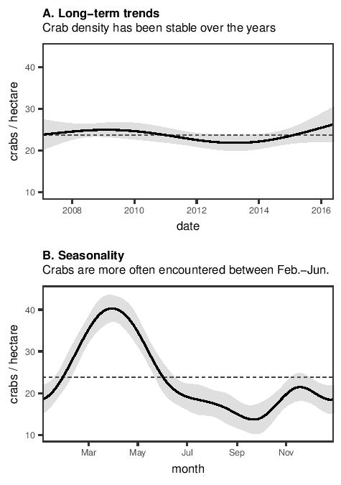

**Figure 3.** Contour plots of the effect of time of the year and distance from shore on (A) the counts and (B) the size of male and female *Birgus latro* respectively.

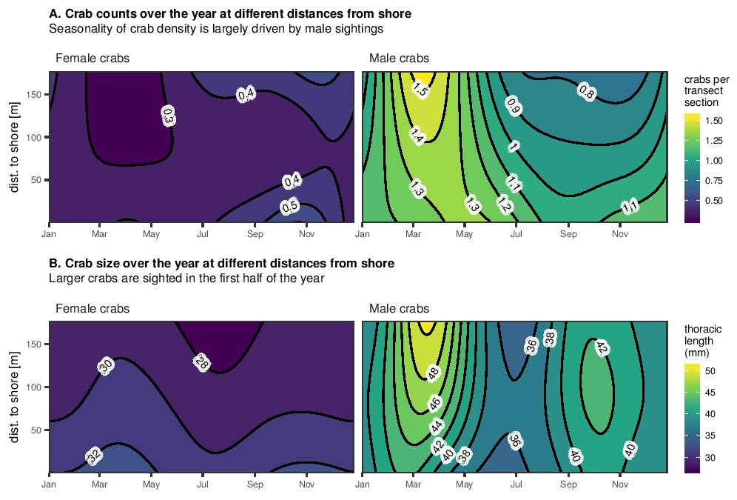

**Figure 4.** Association between the phase of the moon and (A) the count and (B) the size of encountered female (blue) and male (green) *Birgus latro* on Aldabra*.* Y-axes show the effect on the mean counts (0.36 females; 1.13 males) and the mean sizes (thoracic length: 30.5mm for females; 40.6mm for males) per transect section respectively. The solid lines show the values predicted by the Generalised Additive Model, while ribbons represent the standard error. The phase of the moon is defined as 0 and 1 for new moon, 0.25 for first quarter, 0.5 for full moon, and 0.75 for last quarter (Meeus 1982).

D:\Manuscripts\Aldabra coconut crab 2019\Report\Figures\Figure 4.tif

**Figure 5**: Size distribution of female (blue) and male (green) *Birgus latro* encountered on Aldabra.

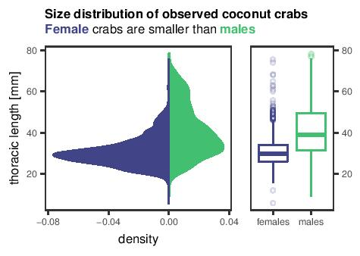

**Figure 6**: Association between time of the year and the mean pleon size for *Birgus latro* females (blue) and males (green) on Aldabra. Pleon size was estimated using an index between 1 and 4 (see text for category descriptions).

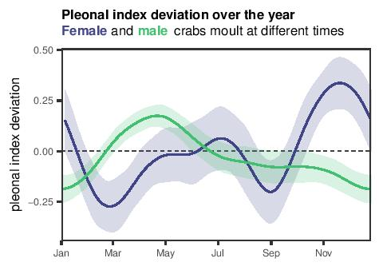

**Figure 7:** Probability of encountering an ovigerous *B. latro* female during a survey on Aldabra from 2007–2016. The solid and dashed lines correspond to the maximum and minimum encounter probability during the moon cycle, respectively. A moon phase of 0.41 corresponds to about three days before full moon and 0.94 to around two days before new moon (Meeus 1982). Grey ribbon indicates confidence interval of the mean probability across the year.

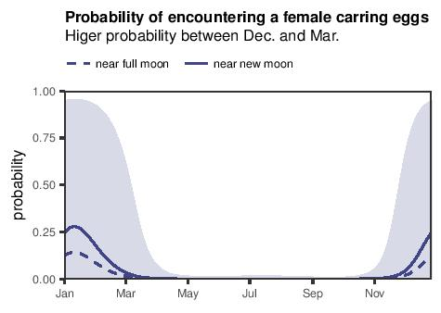

1. *Corresponding author: Jennifer Appoo jcappoo@hotmail.com; ✝These authors contributed equally to the work.